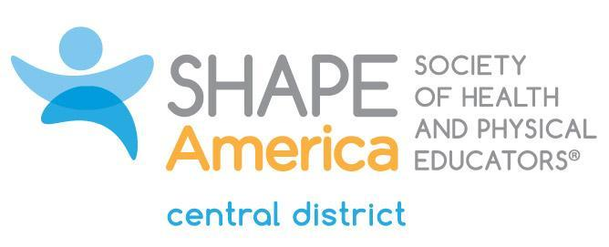

Mark L. Harvey Legacy Future Professional Scholarship
Name:
SHAPE America Member #
Major(s):
College/University:
Year in school:
Current GPA:

Have you attended a state AHPERD/SHAPE convention? |  | How many have you attended?
Have you attended a SHAPE America national convention? |  | How many have you attended?

Have you presented on a topic in the area of HPERD at a state or national convention? If yes, list the convention(s), the topic(s) presented on, and the year(s) below.

List any leadership roles you have held during your collegiate years. (Academic, athletic, or in your community)

In 75 words or less, share why you should be selected to receive the Mark L. Harvey Legacy Scholarship.

In 100 words or less, explain your passion for the HPERD profession.

In 50 words or less, explain where you see yourself professionally in the next 2-5 years.

List two of your mentors and a piece of advice from each of them that they have given you in your quest to become a teacher in the HPERD field.

Application Deadline: January 15
Submit application via email to:
Deb Stephenson - stephensond@sw1.k12.wy.us
The scholarship recipient will be contacted prior to the SHAPE America National Convention.

Mark L. Harvey Legacy Scholarship Acceptance Agreement
The recipient of the scholarship agrees to the following criteria:
- Junior (64-95 credits) and Senior (96+ credits) undergraduate students are eligible to apply.
- Funds from the scholarship must be used to attend the SHAPE America National Convention & Expo.
- Within six weeks of attendance at the convention, submit a report to the Central District Leadership Council including the following information:
  - Receipts to show how the funds were used.
  - The date and site of the SHAPE America National Convention attended.
  - Describe the most beneficial session(s) and what you will do with the information gained.
  - Describe two unique programs, ideas, or innovative presentations from the convention.
Upon agreement to the above criteria the recipient will receive the $500 scholarship amount as follows:
1. A sum of $350.00 will be awarded at the time of acknowledgement.
2. The balance of $150.00 will be awarded upon the Central District Leadership Council’s receipt of the report.

_______________________________________________ __________________________________
Name Date
_______________________________________________ __________________________________
School Address
_______________________________________________ __________________________________
Phone Email Address
Individuals earning this award shall sign and send this agreement to the following individuals:
Megan McCollom - megan.mccollom@mnshape.org
Deb Stephenson - stephensond@sw1.k12.wy.us

